
Data Warehouse
Analytics
Gravity Books

Project Overview

Purpose of the Project
This project implements a Sales Data Warehouse designed to transform raw transactional sales data into structured, analytics-ready datasets. The system consolidates customer, product, and transaction data into a dimensional model to support reporting and business intelligence.

Business Problem it Solves
Operational systems are optimized for transactions, not analytics. Reporting directly from raw transactional data leads to:
- Slow query performance
- Inconsistent calculations
- Data duplication
- Lack of historical tracking
This project solves these issues by:
- Cleaning and standardizing raw sales data
- Creating structured dimension tables
- Centralizing business logic (e.g., revenue calculation)
- Providing a single source of truth for reporting

Type of Data Being Processed
- Sales transactions
- Customer master data
- Product master data
- Pricing and discount information
- Currency information
The data includes structured transactional records and reference data.

Who Uses the Data
The data warehouse is used by:
- Data analysts
- Business intelligence developers
- Dashboard/report developers
- Finance teams
- Sales management

System Architecture

Data Sources
The OLTP system contains:
Core Transaction Tables
- customer
- cust_order
- order_line
- order_history
- order_status
- shipping_method
Product-Related Tables
- book
- author
- book_author (bridge)
- publisher
- book_language
Customer Location Tables
- address
- country
- customer_address
- address_status

Ingestion method
- Batch ETL using SSIS
- Daily incremental loads
- Dimension load before fact load

Processing tools/frameworks
- ETL pipelines (e.g., SSIS or equivalent orchestration tool)
- SQL-based transformation logic

Storage Layers

Layer 1 – Source (OLTP)
Normalized transactional schema.

Layer 2 – Staging
Temporary transformation tables.

Layer 3 – Data Warehouse (Star Schema)
Final Star Schema Tables
Fact Table
- Sales_fact
Dimension Tables
- Customer_dim
- Book_dim
- Author_dim
- Bridge_Book_Author
- Address_dim
- ShippingMethod_dim
- OrderStatus_dim
- Date_dim

Data Flow Explanation
- Extract data from OLTP system.
- Load staging tables.
- Transform:
- Flatten normalized structures.
- Generate surrogate keys.
- Apply SCD logic (Customer_dim, Address_dim).
- Load dimensions.
- Load Sales_fact with foreign keys.
- BI tools query the star schema only.

Data Pipelines Documentation
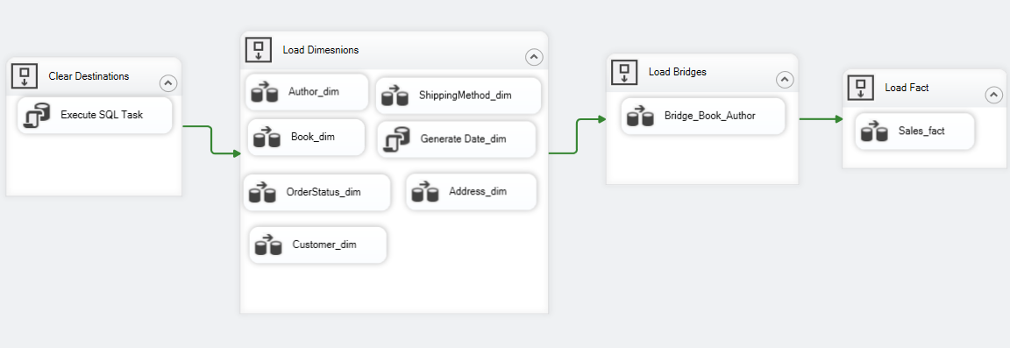

Pipeline 1: Customer Dimension Load
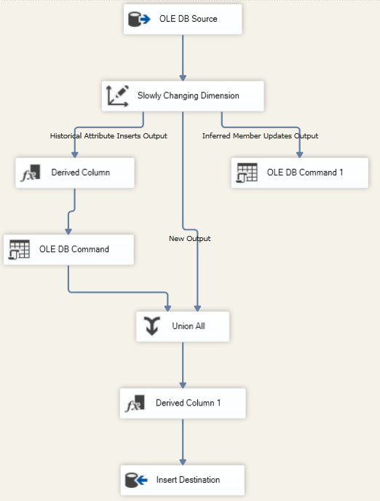
Source:
- customer
Target:
- Customer_dim
Type:
- SCD Type 2
Logic
- Track changes in:
  - first_name
  - last_name
  - email
- Maintain:
  - effective_start_date
  - effective_end_date
  - is_active

Pipeline 2: Address Dimension Load
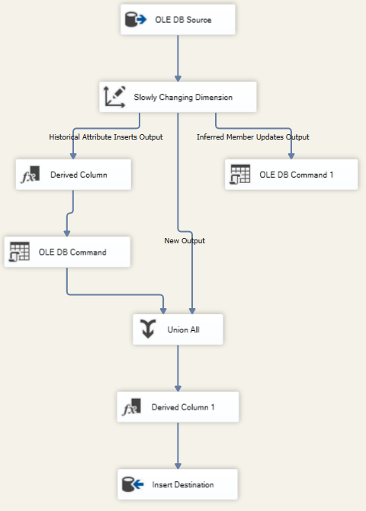
Source:
- address
- country
- customer_address
- address_status
Target: Address_dim
Type:
- SCD Type 2
Logic
- Join address + country
- Track address changes historically
- Manage active flag

Pipeline 3: Book Dimension Load
Source:
- book
- publisher
- book_language
Target:
- Book_dim
Logic
- Flatten publisher_name
- Flatten language_name
- No SCD (assumed Type 1)

Pipeline 4: Author Dimension Load
Source:
- author
Target:
- Author_dim
Simple dimension with surrogate key.

Pipeline 5: Bridge Book Author Load
Source:
- book_author
Target:
- Bridge_Book_Author
Resolves many-to-many relationship between books and authors.

Pipeline 6: Shipping Method Dimension
Source:
- shipping_method
Target: ShippingMethod_dim

Pipeline 7: Order Status Dimension
Source:
- order_status
Target:
- OrderStatus_dim

Pipeline 8: Date Dimension
Source: Generated calendar table
Contains:
- day
- month
- month_name
- quarter
- year
- weekday
- is_weekend

Pipeline 9: Sales Fact Load
Source:
- cust_order
- order_line
- order_history
Target: Sales_fact
Grain
- One record per order line per order.
Foreign Keys
- date_key
- customer_key
- book_key
- shipping_method_key
- shipping_address_key
- status_key
Measures
- quantity
- unit_price
- sales_amount

Data Schema and Data Catalog

Fact Table

Table: Sales_fact
Table Type: Fact Table
Grain: One record per order line per book id.
Column Name | Data Type | Key Type | Business Purpose
sales_key | INT | Surrogate Key (PK) | Unique warehouse identifier for each fact row.
date_key | INT | Foreign Key | Links sale to Date_dim
customer_key | INT | Foreign Key | Links sale to Customer_dim
book_key | INT | Foreign Key | Links sale to Book_dim
shipping_method_key | INT | Foreign Key | Links to ShippingMethod_dim
shipping_address_key | INT | Foreign Key | Links to Address_dim
status_key | INT | Foreign Key | Links to OrderStatus_dim
order_id | INT | Business Key (Degenerate) | Original order identifier from source
quantity | INT | Measure | Number of books sold
unit_price | DECIMAL(10,2) | Measure | Selling price per unit
sales_amount | DECIMAL(12,2) | Measure | Total revenue (quantity × unit_price)

Dimensions Tables

Table: Customer_dim
Table Type: Dimension
SCD Type: Type 2
Column Name | Data Type | Key Type | Business Purpose
customer_key | INT | Surrogate Key (PK) | Warehouse identifier
customer_id | INT | Business Key | Source system identifier
first_name | VARCHAR(200) | Attribute | Customer first name
last_name | VARCHAR(200) | Attribute | Customer last name
email | VARCHAR(350) | Attribute | Customer email
effective_start_date | DATETIME2 | SCD Field | Record validity start date
effective_end_date | DATETIME2 | SCD Field | Record validity end date
is_active | BIT | SCD Field | Indicates active record

Table: Address_dim
Table Type: Dimension
SCD Type: Type 2
Column Name | Data Type | Key Type | Business Purpose
address_key | INT | Surrogate Key (PK) | Warehouse identifier
address_id | INT | Business Key | Source address ID
street_number | VARCHAR(10) | Attribute | Street number
street_name | VARCHAR(200) | Attribute | Street name
city | VARCHAR(100) | Attribute | City name
country_name | VARCHAR(200) | Attribute | Country name
address_status | VARCHAR(30) | Attribute | Address status
effective_start_date | DATETIME2 | SCD Field | Record validity start
effective_end_date | DATETIME2 | SCD Field | Record validity end
is_active | BIT | SCD Field | Indicates active version

Table: Book_dim
Table Type: Dimension
Column Name | Data Type | Key Type | Business Purpose
book_key | INT | Surrogate Key (PK) | identifier
book_id | INT | Business Key | Source book ID
title | VARCHAR(400) | Attribute | Book title
isbn13 | VARCHAR(13) | Attribute | ISBN identifier
language_name | VARCHAR(50) | Attribute | Book language
num_pages | INT | Attribute | Number of pages
publication_date | DATE | Attribute | Publication date
publisher_name | NVARCHAR(1000) | Attribute | Publisher name

Table: Author_dim
Table Type: Dimension
Column Name | Data Type | Key Type | Business Purpose
author_key | INT | Surrogate Key (PK) | Warehouse author identifier
author_id | INT | Business Key | Source author ID
author_name | VARCHAR(400) | Attribute | Full author name

Table: Bridge_Book_Author
Table Type: Dimension
Column Name | Data Type | Key Type | Business Purpose
book_key | INT | Foreign Key | Links to Book_dim
author_key | INT | Foreign Key | Links to Author_dim

Table: ShippingMethod_dim
Table Type: Dimension
Column Name | Data Type | Key Type | Business Purpose
method_key | INT | Surrogate Key (PK) | Warehouse shipping method ID
method_name | VARCHAR(100) | Attribute | Shipping method name
cost | DECIMAL(6,2) | Attribute | Shipping cost

Table: OrderStatus_dim
Table Type: Dimension
Column Name | Data Type | Key Type | Business Purpose
status_key | INT | Surrogate Key (PK) | identifier
status_id | INT | Business Key | Source status ID
status_value | VARCHAR(20) | Attribute | Status description

Table: Date_dim
Table Type: Dimension
Column Name | Data Type | Key Type | Business Purpose
date_key | INT | Surrogate Key (PK) | Date in YYYYMMDD format
full_date | DATE | Attribute | Actual calendar date
day | INT | Attribute | Day of month
month | INT | Attribute | Month number
month_name | VARCHAR(20) | Attribute | Month name
quarter | INT | Attribute | Quarter number
year | INT | Attribute | Year
weekday | VARCHAR(20) | Attribute | Day name
is_weekend | BIT | Attribute | Weekend indicator

Data Modeling
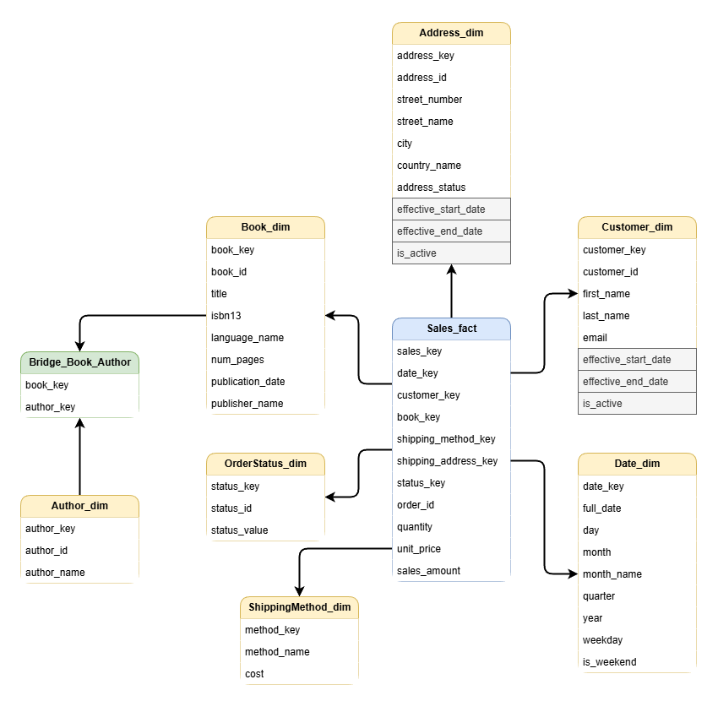

Business Rules

Sales Amount Calculation
- sales_amount = quantity × unit_price

Status Logic
- Latest status from order_history determines fact status.

Address Logic
- Shipping address used from cust_order.dest_address_id.

SCD Rules
- Customer and Address use Type 2.

Data Quality Rules
- No null foreign keys in fact table
- Quantity > 0
- Price ≥ 0
- Valid status values
- No duplicate order_line entries
- Referential integrity enforced
Failed rows: Redirected to error table

Data Ownership

Business Owner
- Head of Sales Operations

Technical Owner
- Data Engineering Team

Analytics using Power BI
